**INTRODUCTION:**

**E-Parking** is the act of stopping and disengaging a [vehicle](https://en.wikipedia.org/wiki/Vehicle) and leaving it unoccupied. Parking on one or both sides of a road is often permitted, though sometimes with restrictions. Some buildings have parking facilities for use of the buildings' users. Countries and local governments have rules for design and use of [parking spaces](https://en.wikipedia.org/wiki/Parking_space). Where car parking spaces are a scarce commodity, and owners have not made suitable arrangements for their own parking*.* [overspill parking](https://en.wikipedia.org/wiki/Overspill_parking) often takes place along sections of road where there is no planned scheme by a Heated social discourse sometimes revolves around the sense of "ownership" that informally arises. Many use [parking chairs](https://en.wikipedia.org/wiki/Parking_chair) and other markers, usually without approval of municipal authorities. Festivals and sporting events often spawn a cottage industry of parking. Homeowners, schools, and businesses often make extra money by charging a [flat-rate](https://en.wikipedia.org/wiki/Flat-rate) [fee](https://en.wikipedia.org/wiki/Fee) for all-day parking during the event. In some countries, such "cottage industry parking" has become large-scale business. The UK airport parking industry is currently estimated to be worth 1.3 billion GBP per year.

According to the International Parking Institute, "parking is a $25 billion industry and plays a pivotal role in transportation, building design, quality of life and environmental issues”. Some airports charge more for parking cars than for parking aircraft.

Parking control is primarily an issue in densely populated cities in advanced countries, where the great demand for parking spaces makes them expensive and difficult. In urban locations parking control is a developing subject. Parking restrictions may be public or private. Local government, as opposed to central government, is the primary activator in public parking. The emphasis is on restriction of on-street parking facilities; and parking charges and fines are often major income sources for local government in North America and Europe.

Typically, communication about the parking status of a roadway takes the form of notices, e.g. fixed to a nearby wall and/or road markings. Part of the requirements for passing the driving test in some countries is to demonstrate understanding of parking signs.

.

**Performance E-Parking**

[Donald C. Shoup](https://en.wikipedia.org/wiki/Donald_C._Shoup) in 2005 argued in his book, *The High Cost of Free Parking*, against the large-scale use of land and other resources in urban and suburban areas for motor vehicle parking. Shoup work has been popularized along with market-rate parking and performance parking, both of which raise and lower the price of metered street parking with the goal of reducing cruising for parking and double parking without overcharging for parking.

"Performance parking" or variable-rate parking is based on Dr Shoup's ideas. Electronic parking meters are used so that parking spaces in desirable locations and at desirable times are more expensive than less desirable locations. Other variations include rising rates based on duration of parking. More modern ideas use sensors and networked parking meters which "bid up" (or down) the price of parking automatically with the goal of keeping 85–90% of the spaces in use at any given time to ensure perpetual parking availability. These ideas have been implemented in Redwood City, California and are being implemented in [San Francisco](https://en.wikipedia.org/wiki/San_Francisco_congestion_pricing#SFpark_variable_pricing_initiative) ]and [Los Angeles](https://en.wikipedia.org/wiki/Los_Angeles).

|  |
| --- |
|  |

## Pay with cash

The [first parking meters](http://www.parking-net.com/about-parking/history-of-parking) only accepted coins. Nowadays, you can still pay with coins (and paper money) at most parking meters and – terminals. However, other payment options are integrated more and more.   
The disadvantage of paying with cash, is that you always have to carry loose change with you. Another disadvantage of paying by cash is that you have to determine the amount of time you want to park in advance: You insert the coins before you go your way, but you don’t always know exactly how long you will be gone. This means that sometimes you pay for time you don’t actually spend, or you are so caught up in what you’re doing that you exceed the time limit.

**IMPLEMENTATION:**

SOFTWARE REQUIRED:

1.VISUAL STUDIO 2012 ULTIMATE

2.SQL SERVER 2005

HARDWARE REQUIRED:

1. OPERATING SYSTEM: WINDOWS 7,WINDOWS XP

2. 32-BIT PROCESSOR,4GB RAM,500GB HARDDISK,INTEL CORE PROCESSOR UPTO LATEST VERSION

**DATAFLOW DIAGRAM:**

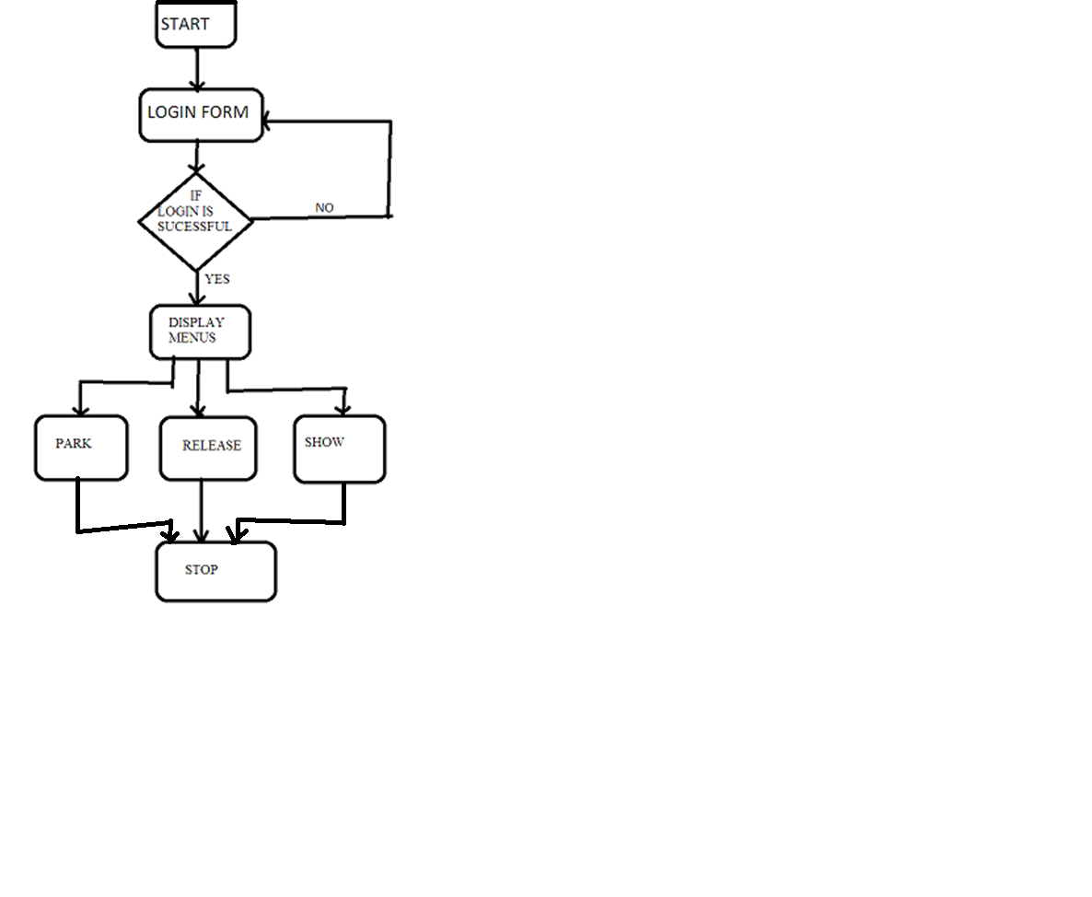

**WORKING:**

**In this project eparking information collect.This project includes number of module.the module is very important for the project,there are more than five modules are very important role in project.**

**In this project the first design the module of the menu. That menu what the information to be fill in the particular form.** Parking control is primarily an issue in densely populated cities in advanced countries, where the great demand for parking spaces makes them expensive and difficult. In urban locations parking control is a developing subject. Parking restrictions may be public or private. Local government, as opposed to central government, is the primary activator in public parking. The emphasis is on restriction of on-street parking facilities; and parking charges and fines are often major income sources for local government in North America and Europe.

**1.displaying a menu**

In project the menu arediaplay on the particular form that are considered to be all menus are in the particular form.there are number of menus to display on the form such are park,release,add price,delete and shoe etc. menu are display in the menu form.when the click on the park menu there is the showing the various textboxes .that textboxs is used for the filling the information about the vehicle parking.there are number of information can be fill in the particular space.

**2.filling detail**

That the project is ready to run first filling the information about the vehicle which is come for the parking.all the information which is important to store the particular vehicle owner.when the vehicle is come for the parking ,first check the that vehicle no. plate or not.then the first fill the name of the vehicle owner.then the that vehicle number,mobile number is very important for further process.then which type of vehivle for parking.which person for parking a vehicle that person such type any document id is important and that id number is also important.when the vehicle is to be release then the select the date then vehicle number then to display the detail of that vehicle .

**3.vehicle parking detail:**

In the project ,which type of vehicle is to be parking is come. That vehicles all information is to be display on the show form. In that project the park vehicles details to be see then simply choosing a particular date and then click to show all the detail about the how many vehicles to be park and which type of vehicles is park. In another which vehicle is to be release on the particular date is to be see. That the in this project all the information about the parking.

**E-PARKING VIEW:**

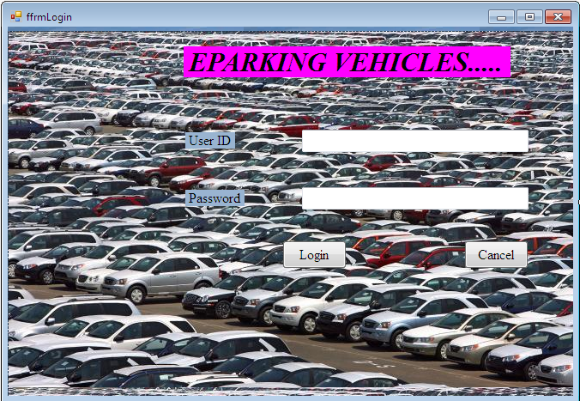

**Fig no:1**

Displaying the log in form.

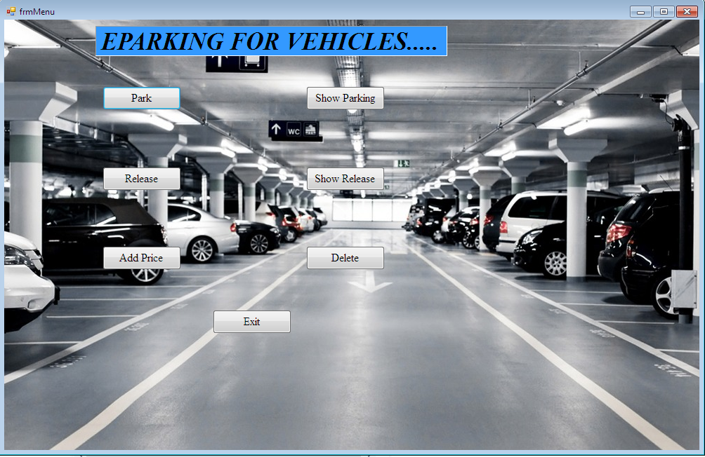

**Fig no:2**

**All menus are present in above window.**

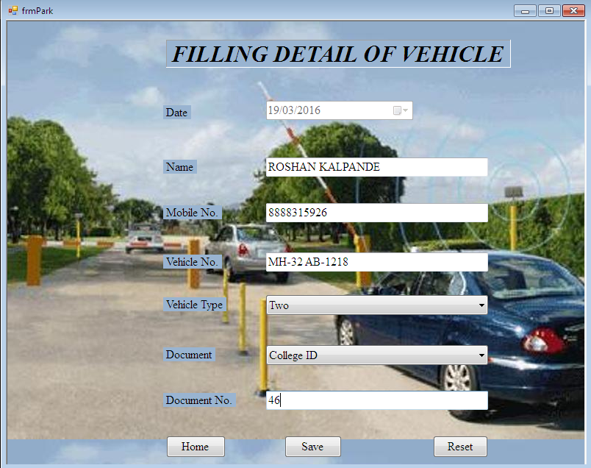

**Fig no:3**

**Entering the information about the the vehicle which coming for the parking.**

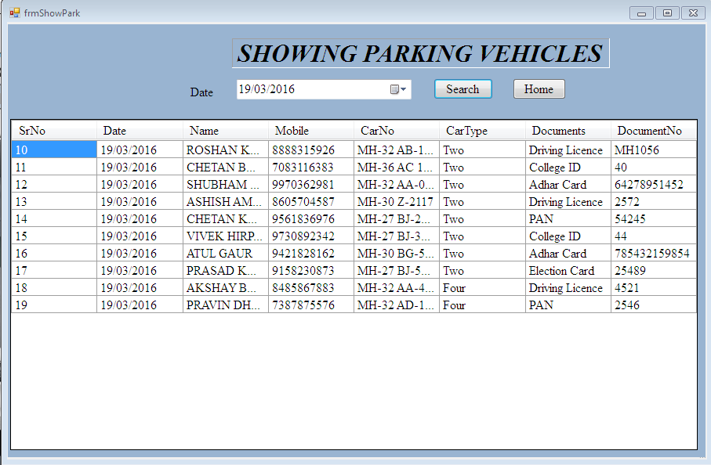

**Fig no:4**

**Showing parking vehicles detail.**

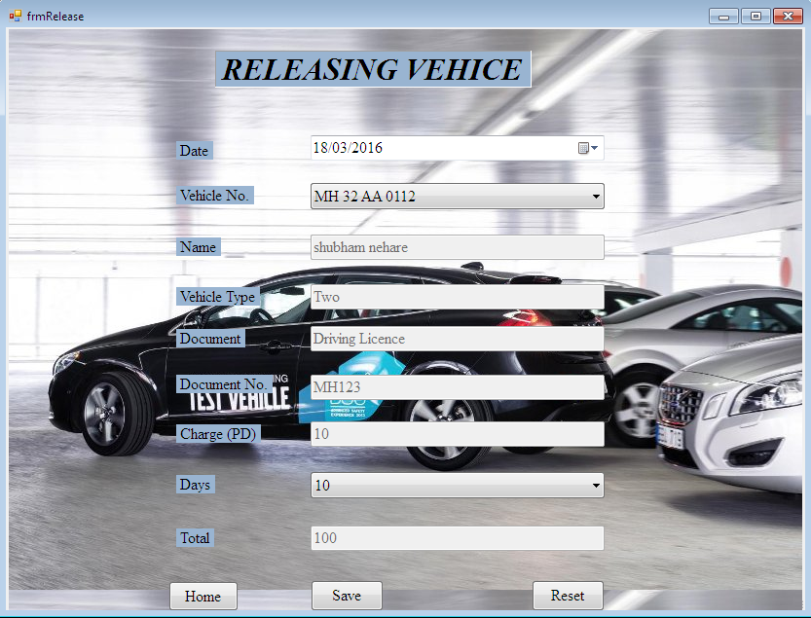

**Fig no:5**

**Release the vehicle from the parking.**

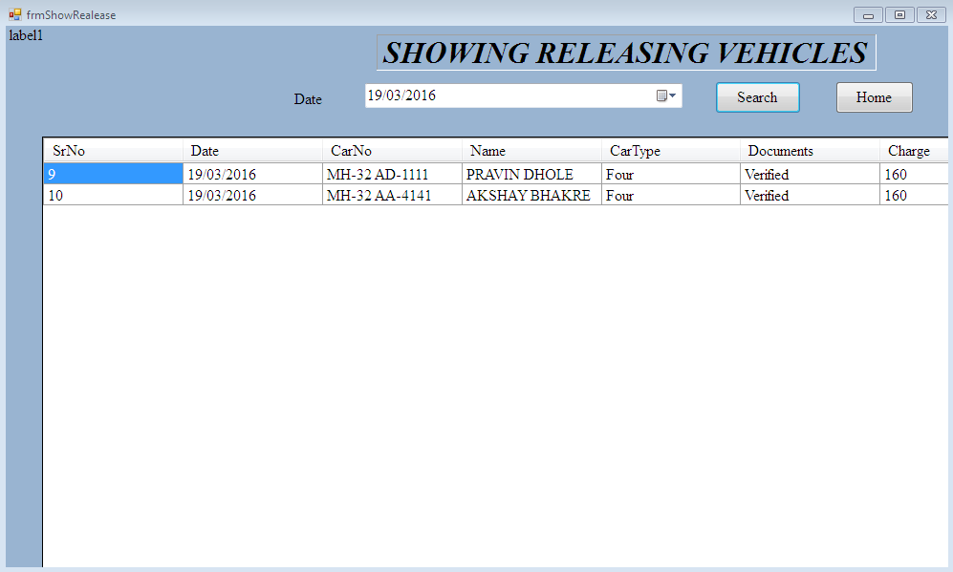

**Fig no:6**

**Showing the releasing vehicles from parking is display particular date.**

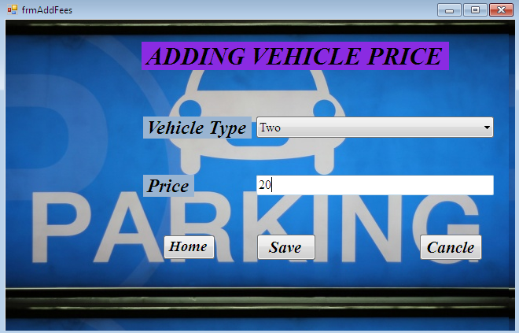

**Fig no:7**

**Adding a price**

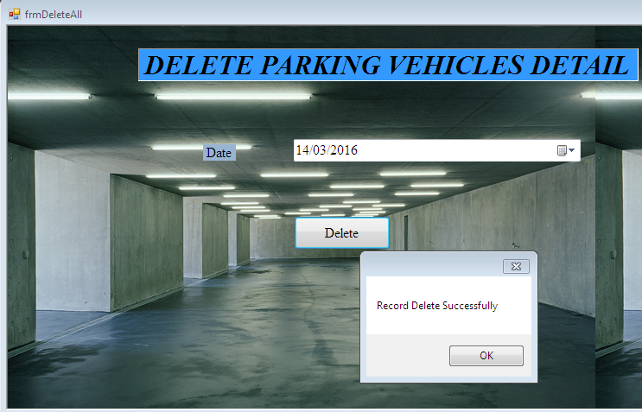

**Fig no:8**

**Deleting the detail of vehicle parking**

**Advantages of E-Parking:**

* **1.Efficiency**  
  **2.Cost effective**  
  **3.Saves Time**

|  |
| --- |
| * **4.Easy and cost effective maintenance** **5.Car Safety** **6.Safer for drivers** **7.Environment Friendly** |

* Provides for safety, movement and servicing requirements at specified times, whilst providing for parking at other times.
* Largely self enforcing for preventing parking by train commuters.
* Permit holders ( residents) can park at any time ( permits would need to be charged )
* Some turn over occurs if enforcement is undertaken
* Straight forward to enforce
* Income to cover operational costs plus possible excess
* Can cater for any period of parking Control usage ( i.e. availability) by charging rates.

**FUTURE SCOPE:**

E- parking systems are designed to be efficient. By not requiring space for cars to drive in and out, and no space needed for pedestrians, these systems can park the same or more cars than a traditional car garage twice as large. It's believed that these systems will solve the growing demand for parking worldwide.

The automated systems works very simply; a driver drives into the car park bay and then exits and leaves their car. The computerized system then activates lifts to take the car to the nearest open spot. When the driver wishes to recall the vehicle, they just request it from a computer terminal outside of the car park and within 3 minutes the car is returned and the driver can drive off.

These parking systems are typically smaller than conventional parking garages. Using nearly half of the space, they can park the same or more number of cars than the conventional garage. This is due to the inefficiencies of the traditional car garage. Automated systems are also safer than the current norm. Being safely housed in a building with no traffic and no people ensures the vehicle is safe from dents, scratches and minor accidents but also from vandalism and theft.

They are also more convenient as a driver doesn't spend time searching for a spot, walking to and from their car and there's never a worry of forgetting where they parked. As a bonus, these systems are also green. With no cars driving in and out of the building, the amount of pollution is reduced to nearly zero.

All of these factors together combine to make parking garages the future of parking. Experts have already predicted that implementing these automated systems parking will reduce the demand for the increasingly rare parking spot.

**CONCLUSION:**

This system is easy to understand and use. The people are going to any city then the then the vehicle is park in the E-Parking system if they are going via plane or train. E-Parking is the act of stopping and disengaging a [vehicle](https://en.wikipedia.org/wiki/Vehicle) and leaving it unoccupied. Parking on one or both sides of a road is often permitted, though sometimes with restrictions.

That reason the E-Parking is used. The E-Parking system is to be more vehicles detail can store in a particular format so ,it is easily to handle.

The main goal of the E-Parking system pollution to be controlled and city space is free for other work.